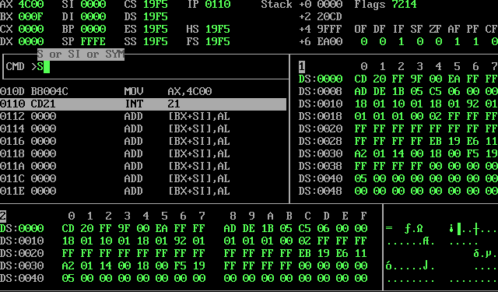

Q1 : B8
Q2 : Line 4 and Line 9
Q3 : B8 is the op code of “mov ax, constant” instruction and “0500” is the value of the constant in hexadecimal or operand of the instruction in Little endian notation.
Q4: BB
Q5: 0100
Q6: Each of the instructions are of 3 bytes
Q7: 18 bytes
Q8: Verified

Activity 4:
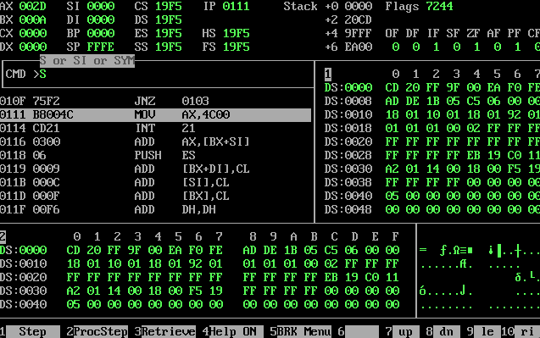
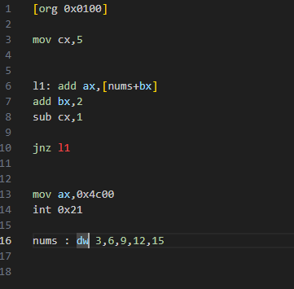

Activity 5:
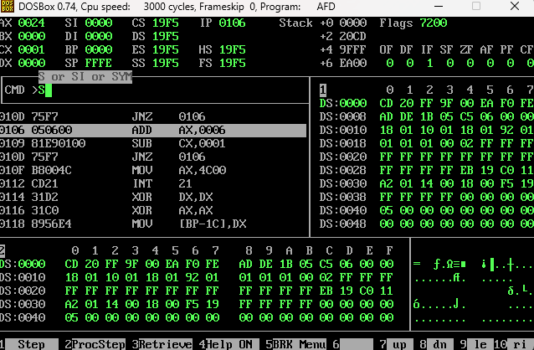
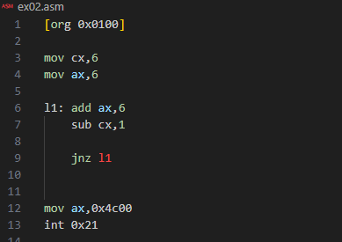

Activity 4 updated :

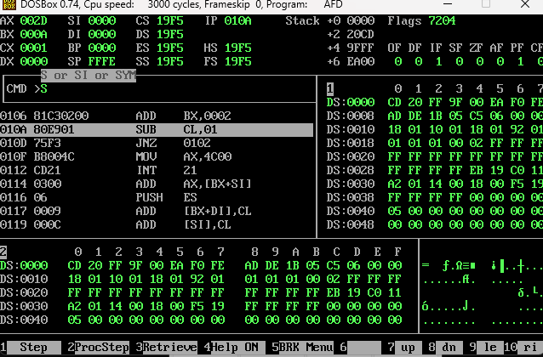
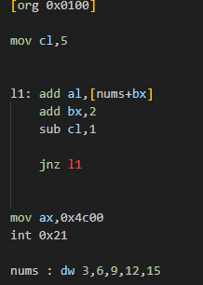
Activity 5 updated:
